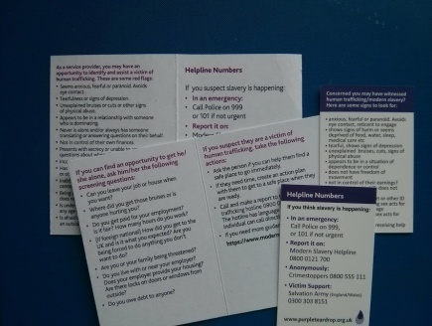
These aides memoire are useful to trainers, front line workers, voluntary organizations raising awareness of slavery/human trafficking, companies supporting staff or concerned about their supply chains ..... and the small cards particularly for the general public who may have their suspicions.

QTY | TYPE |  | COST/ pack | No of packs | Total Cost | 10%Conf Discount |  | Final Cost
25 | Small cards |  | £3.00
50 | Small cards |  | 5.00
100 | Small cards |  | 9.00
25 | Front line workers cards |  | 3.50
50 | Front line workers cards |  | 8.00
100 | Front line workers cards |  | 12.00
 |  |  |  |  |  | £
Name:
Email:
Club/Org
Address
Inc
Post Code

√
Payment can be made by cheque, made payable to Purple Teardrop Campaign, and sent with your ref to: Purple Teardrop Campaign, c/o Beech House, 28 Wimborne Road, Poole BH15 2BU, or

by BACS: CAF Bank, Account No 00021577 Sort Code 40-52-40. Please put your surname as the Reference so that we can match payment with order, thank you.

Should you require a larger quantity we would be able to quote slightly more favourably – please ask if this is a possibility for you as we are trying to supply these as cost-effectively as possible. To gain a cost advantage on quantity, orders would need to be in quantities of 1,000, 2,000, or 5000+. Contact enquiries@purpleteardrop.org.uk

